GenAI – March – Home Work – Week 2 Day 2
S01 - DOM to Selenium Code-HW
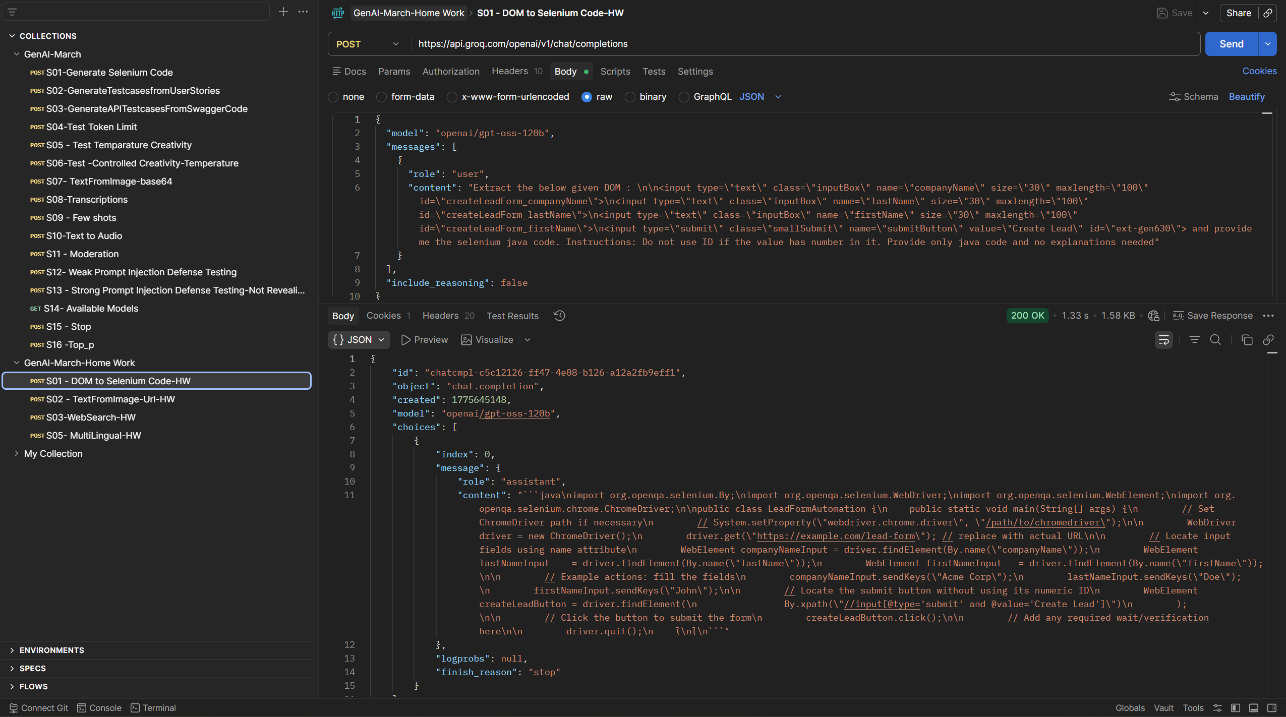

S02 - TextFromImage-Url-HW
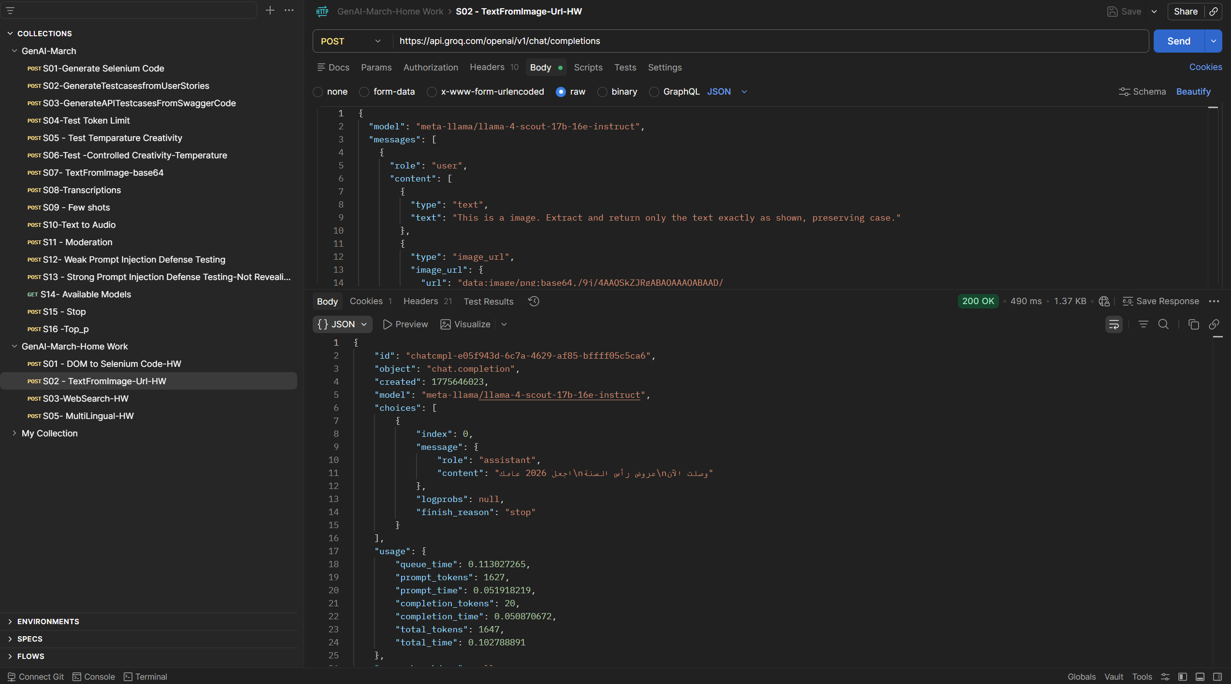

S03-WebSearch-HW
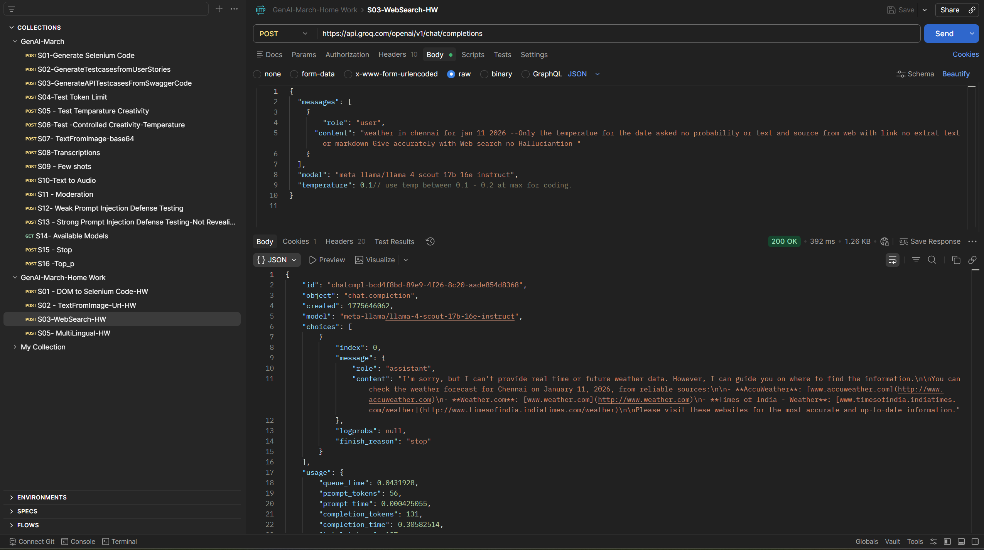

S05- MultiLingual-HW
